Table of Contents
CAMERA SENSOR INFORMATION 2
OV5640 SENSOR INFORMATION 13
Camera interface 15
parallel 15
CSI-1 16
CSI-2 16

CAMERA SENSOR INFORMATION

1) What is a camera ?
A device which captures the ambient light and converts it to an image or video. The term camera comes from the word camera obscura (Latin for "dark chamber"), an early mechanism for projecting images.
Types –
- Analog Cameras
- Digital Cameras

2) what is analog camera ?
Analog cameras use films which are exposed for a period defined by opening of the shutter to produce images.

3) Blocks of camera (digital)
- Image sensor
- Color Filter array
- Lens
- Digital Image processor

4) what is image sensor?

- An image sensor is a solid-state electrical device that converts light (photons) to electronic signal form.
- The sensor has many tiny wells known as pixels, and in each pixel there will be a light sensitive element which can sense how many photons have arrived at that particular location. The charge output from each location is proportional to the intensity of light falling onto it.
- This charge has to be converted into a signal, amplified and then converted to digital form.
- The first digital camera used a charge-coupled device was invented by Steven Sasson, an engineer at Kodak Company.

5) Anatomy of camera sensor?

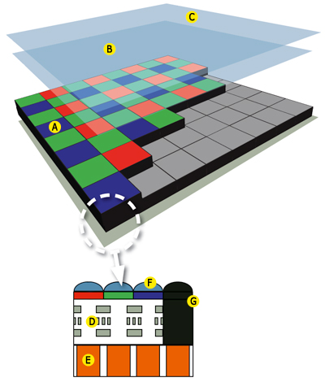
A - Color Filter Array
B – Low pass filter
C – IR filter
D – Circuitry
E - Pixel
F – Micro lens
G – Black pixels

6) Image Sensor Types

There are mainly two types of image sensors
- CCD (Charge Coupled Devices)
- CMOS(Complementary Metal Oxide Semiconductors)

7) CCD Sensor operation?
In CCD sensors the charges are read out through limited nodes, buffered, amplified and then converted to digital values

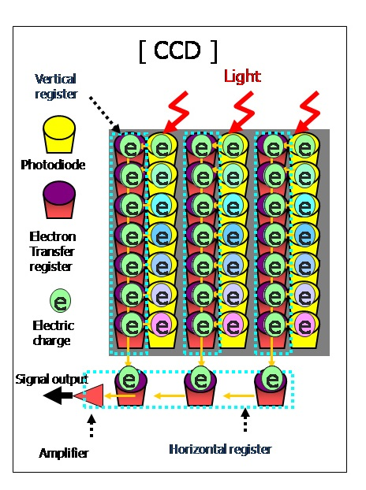

8) CMOS Sensor operation?
CMOS sensors are similar to CCD sensors in capturing the charge in wells but use individual transistors for transferring the charge through each pixel.

9) CCD VS CMOS ?
- CMOS is cheap , consumes less power, and are small but they also produce grains.

- CCD has high sensitivity to light, produces better and less noisy images, but is big, consumes more power and are costly to manufacture

10) Common Terminology in Camera ?Common terminologies

- Pixel – The individual photo detector on the sensor.
- Frame – A combination of rows and columns of pixels to form an image.
- Frame rate – Number of images played per second.
- Resolution – spatial arrangement of the pixels in a camera

- 320 * 240 - QVGA
- 640 * 480 - VGA
- 1280 * 720 - 720P – HD
- 1280 * 960 - 960P – Full HD
- 1920 * 1080 - 1080P - 2MP
- 1600 * 1200 - UXGA - 3MP
- 2048 * 1536 - QXGA - 3MP
- 2592 * 1944 - QSXGA - 5MP

11) what is mean by scanned by camera ?

There are mainly two ways in which an image is scanned by the camera
- Interlaced scanning in which odd and even lines are scanned sequentially.
- Progressive scanning in which all the lines are scanned sequentially.



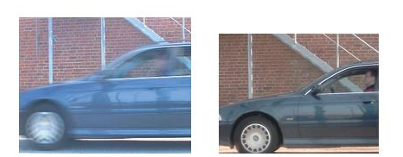

12) Camera lens and it's action
A camera lens is used to project the image onto a sensor array so that it can be converted to an image.
Parameters:
- Aperture
- Focus
- Zoom

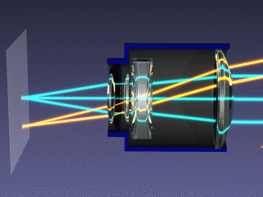
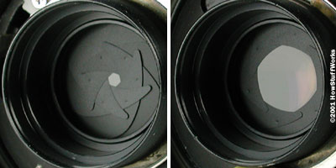

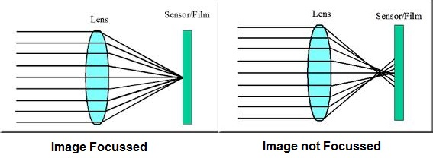

13) what is shutter?
A shutter when closed blocks the light entering into the camera and when open allows the light to pass through.
Types
- Mechanical shutter
- Electronic rolling shutter
- Electronic global shutter

- Mechanical shutters rotate in front of the film and allow light to pass through slits so that image will get exposed for a small time.

- In digital cameras, the shutter action is controlled electronically to avoid the use of mechanical components.

- Global shutter cameras start the initiation and termination of all the pixels at the same time to avoid smear effects
14) camera sensor parallel interface signals ?
The camera sends out the following signals:
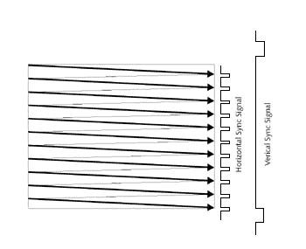
- Pixel clock
- Frame Valid
- Line Valid
- Data

15) camera sensor MIPI CSI interface signals ?
MIPI or Mobile Industry Processor Interface was founded in 2003 by ARM,Intel, Nokia, Samsung, STMicro and TI, to establish a standard interface that can be used with all devices.

The MIPI standard has Camera Serial Interface of 1 to 4 lanes to transfer data serially and a clock signal and Camera control interface to transfer control signals.
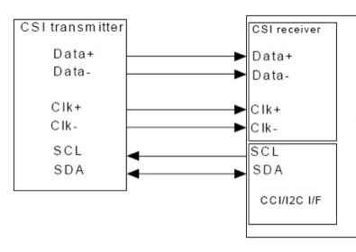

It uses Low Voltage differential signaling which uses polarity of the signals to determine whether the data is 1 or 0.

16) What is BAYER Format ?
- RAW output of the sensor is also called as Bayer format.
- It uses an arrangement RGB color filters in patterns of RGBG , GRGB or RGGB.
- It uses twice the amount of green component to mimic the human eye
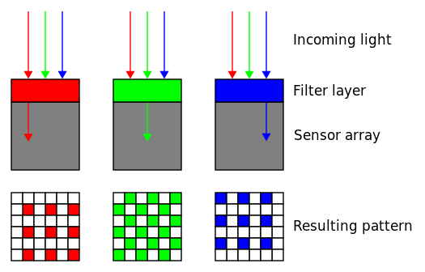
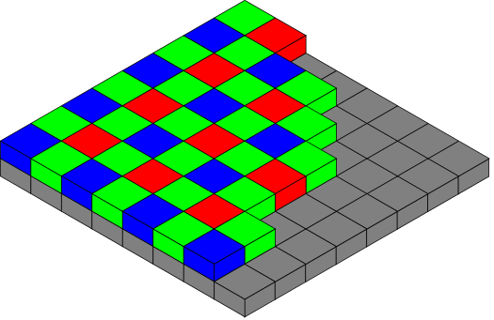

16) What is BAYER Interpolation methods?
Interpolation is used to convert the RAW Bayer data to RGB color format.
Mostly we use two major interpolation methods.
- Nearest neighbor method
- Bilinear interpolation method

17)Nearest neighbor method

This method takes the nearest neighbor as the pixel value and hence has least quality

At position of R14
G14 = G8 (or) G13 (or) G15 (or) G20.
B14 = B7 (or) B9 (or) B19 (or) B21.
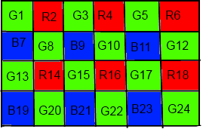

18)Bilinear interpolation method

This method averages the surrounding pixels and hence has better quality
G14 = (G8 + G13 + G15 + G20) / 4
B14 = (B7 + B9 + B19 + B21) / 4
Also in some other location, say we will calculate Red and Blue at G15
R15 = (R14 + R16) / 2
B15 = (B9 + B12) / 2

18)what is exposure?
- The exposure of a camera is defined as the duration for which the pixels are illuminated.
- Only after the pixels are exposed they can be read out of the sensor, and hence longer exposure times will reduce the frame rate.
- Some sensors provide a Strobe signal that can be used to measure the exposure time

19) what is gain ?

Gain is an electronic amplification of the video signals.
By applying gain the overall signal intensity is improved and hence it provides a brighter image.
Types
- Global Gain
- Individual channel gains

19) what is brightness?
Brightness refers to the overall lightness or darkness of an image.
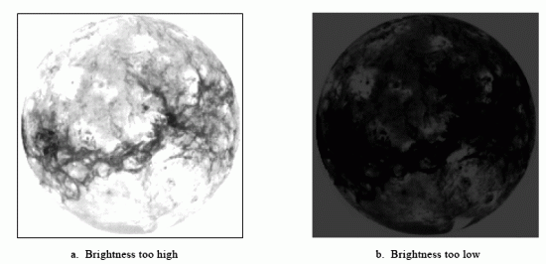

19) what is contrast?
The contrast of an image is the difference in luminance and color that makes an image more distinguishable.

20) what is white balance?
White balance is the process of removing unrealistic color casts on images. It takes into account the color temperature of the source.
Auto white balance.

21) what is Hue?
Hue control involves changing of wavelengths of primary and tertiary colors in the image


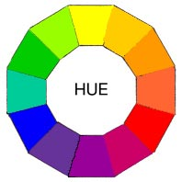

22) what is Saturation?
Saturation is used to describe the intensity of the color in the image, an over saturated image produces overly bright colors

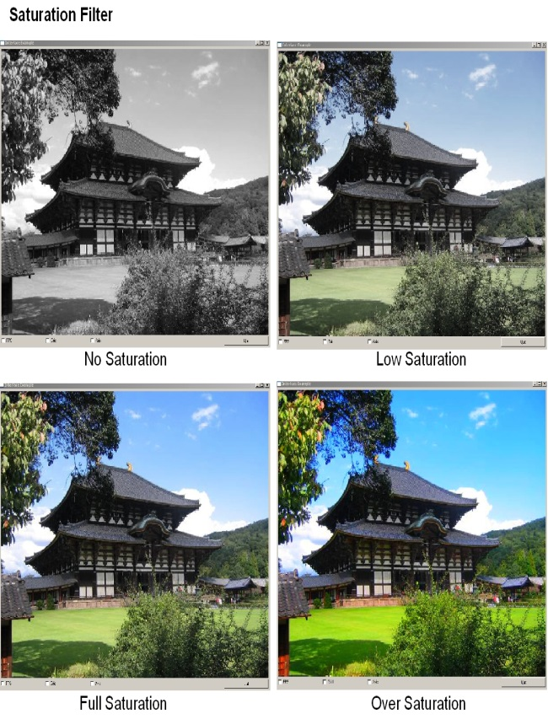

23) what is power line frequency control?
Power line frequency control is used in order to match exposure of the camera with the frequency of the lighting being used.
- Failure to do this will cause flickering

24) what is Binning
There are three types of binning available: horizontal binning, vertical binning, and full binning. Binning in general will combine the information of adjacent pixel into a resulting information depending on binning mode. That will in any case lead to a reduced resolution by the factor of binning. But also it will sum the performance of each single pixel.

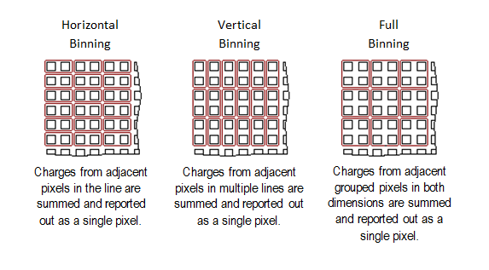
The reason for being of binning is to increase the signal-to-noise ratio (SNR or noise reduction), a key metric in analog applications (such as image sensing). In modern camera, this is particularly useful to obtain higher brightness in extreme low-light conditions.

25) Shutter Speed
Shutter speed is a measurement of the time the shutter is open, shown in seconds or fractions of a second: 1 s, 1/2 s, 1/4 s … 1/250 s, 1/ 500 s, etc. The faster the shutter speed, the shorter the time the image sensor is exposed to light; the slower the shutter speed, the longer the time the image sensor is exposed to light.

OV5640 SENSOR INFORMATION
optical size of 1/4"
automatic image control functions: automatic exposure control (AEC), automatic white balance (AWB), automatic band filter (ABF), automatic 50/60 Hz luminance detection, and automatic black level calibration (ABLC)
programmable controls for frame rate, AEC/AGC 16-zone size/position/weight control, mirror and flip, cropping, windowing, and panning
image quality controls: color saturation, hue, gamma, sharpness (edge enhancement), lens correction, defective pixel canceling, and noise canceling
support for output formats: RAW RGB, RGB565/555/444, CCIR656, YUV422/420, YCbCr422, and compression
support for video or snapshot operations
support for horizontal and vertical sub-sampling, binning
digital video port (DVP) parallel output interface and dual lane MIPI output interface
support for images sizes: 5 mega pixel, and any arbitrary size scaling down from 5 mega pixel
support for auto focus control (AFC) with embedded AF VCM driver
active array size:2592 x 1944
power supply:
core: 1.5V ± 5% (with embedded 1.5V regulator)
analog: 2.6 ~ 3.0V (2.8V typical),
I/O: 1.8V / 2.8V
Input clock frequency:6~27 MHz
maximum image transfer rate:
QSXGA (2592x1944): 15 fps
1080p: 30 fps
1280x960: 45 fps
720p: 60 fps
VGA (640x480): 90 fps
QVGA (320x240): 120 fps
shutter:
rolling shutter / frame exposure
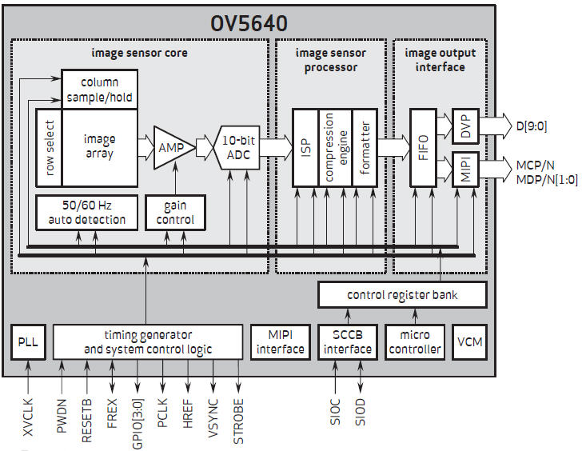

Camera interface

parallel
Camera Interface block is the hardware block that interfaces with different image sensor interfaces and provides a standard output that can be used for subsequent image processing.
A typical Camera Interface would support at least a parallel interface although these days many camera interfaces are beginning to support the MIPI CSI interface.
The camera interface's parallel interface consists of the following lines :-
8 to 12 bits parallel data line
These are parallel data lines that carry pixel data. The data transmitted on these lines change with every Pixel Clock (PCLK).
Horizontal Sync (HSYNC)
This is a special signal that goes from the camera sensor or ISP to the camera interface. An HSYNC indicates that one line of the frame is transmitted.
Vertical Sync (VSYNC)
This signal is transmitted after the entire frame is transferred. This signal is often a way to indicate that one entire frame is transmitted.
Pixel Clock (PCLK)
This is the pixel clock and it would change on every pixel.

CSI-1
CSI-1 was the original standard MIPI interface for cameras. It emerged as an architecture to define the interface between a camera and a host processor. Its successors were MIPI CSI-2 and MIPI CSI-3, two standards that are still evolving.

CSI-2
The MIPI CSI-2 v1.0 specification was released in 2005. It uses either D-PHY or C-PHY (Both standards are set by the MIPI Alliance) as a physical layer option. The protocol is divided into the following layers:
- Physical Layer (C-PHY/D-PHY)
- Lane Merger Layer.
- Low Level Protocol Layer.
- Pixel to Byte Conversion Layer
- Application Layer

